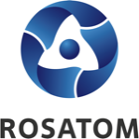 | Rosatom digital  press office  https://atommedia.online/en/ | Press release  13.11.24

Rosatom demonstrated technological solutions in the field of clean energy at the VII China International Import Expo
More than 3,500 representatives from 129 countries attended the event and presented their products, technologies, and services

Rosatom took part in the China International Import Expo (CIIE), which ended on November 10. At one of the largest trade fairs in China, created for the development of international economic cooperation, Rosatom presented an interactive model of the “city of the future” at their booth to demonstrate Russian developments in the field of large and small NPPs, nuclear fuel cycle closure, as well as new business areas – wind power, nuclear medicine, and logistics solutions. A special section of the exhibition exposition was devoted to the history of long-term cooperation between Russia and China in nuclear power and other areas.

