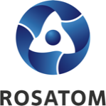 | Rosatom digital  press office  https://atommedia.online/en/ | Press release  16.10.24

Alexey Likhachev, Director General of Rosatom, held a working meeting with Aleksandar Vulin, Deputy Prime Minister of Serbia

On October 16, 2024, a meeting was held between Alexey Likhachev, Director General of Rosatom, and Aleksandar Vulin, Deputy Prime Minister of the Republic of Serbia.

During the meeting, the parties discussed the issues of expanding cooperation in the field of non-energy use of nuclear technologies, attracting Serbian companies to implement projects in third countries, as well as possible participation of Russian companies in high-tech projects in Serbia.

For reference:

Serbia has a law prohibiting its officials from discussing the issues of building nuclear power and nuclear fuel cycle facilities in the country. At the moment, removal of these restrictions is being considered.

