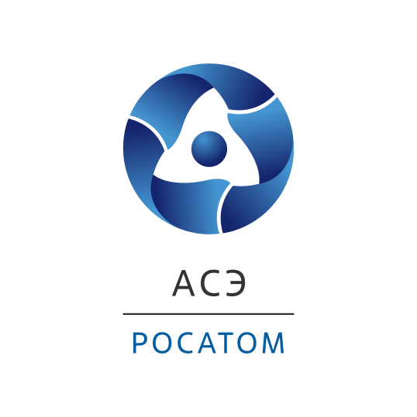

**TEAM, the 10th International Scientific and Practical Conference of Young Nuclear Scientists and Specialists Has Been Held in St. Petersburg**

TEAM-2023, the 10th International Scientific and Practical Conference of Young Nucldar Scientists and Specialists was organized by the Youth Society of Atomenergoproekt JSC St. Petersburg Branch Office - St. Petersburg Design Institute (Rosatom Engineering Division) and hosted about 350 participants from various countries.

“It's nice to see that the TEAM conference made up and first held by St. Petersburg engineers in 2009, is evolving through expanding the geography of its participants and increasing the number of areas for discussion. In 2023, the conference is hosting young specialists from Russia, Egypt, Turkey, Algeria, Belarus, Nigeria, Ghana, Sri Lanka, Kazakhstan and Uzbekistan. It is they who will have to work in the nuclear and related industries in the future and guarantee technological and energy sovereignty in their countries,” said Konstantin Ilyinsky, the First Deputy General Director - Director of Atomenergoproekt JSC St. Petersburg Branch Office - St. Petersburg Design Institute.

In this year, the foreign community has been represented by specialists of AKKUYU NÜKLEER (Turkey), CRNA/COMENA (Algeria), NPPA (Egypt) companies and foreign students of St-Petersburg Polytechnical University named after Peter the Great, Тomsk Polytechnical University and NRNU MEPhI.

The TEAM International Conference is held on a biennial basis. In 2023, the main topic of the event was focused on youth solutions to achieve technological leadership through the implementation of innovations in the nuclear industry. In addition to the tight agenda of the business programme, Russian and foreign young specialists visited St. Petersburg industrial enterprises, such as the Baltic Plant, Izhora Plant, Leningrad Metallic Plant and NIIEFA JSC; moreover, they got acquainted with the NPP virtual control room designed by the St-Petersburg design institute specialists and allowing to calculate and justify all technological solutions for the future nuclear power plant at the design stage.

As part of the conference, 13 topical workshops were held. The participants discussed topical issues in the following areas: Automatic process control systems in nuclear projects; closed nuclear fuel cycle. Management of radioactive waste and spent nuclear fuel; Survey, design and construction of nuclear power facilities; Information modeling; International youth research in the field of nuclear energy; Safety analysis of nuclear facilities; Commissioning and operation, lessons leaned; Design analysis of structures, systems and components; Thermonuclear fusion; Chemical technology and materials study; Power plants; Youth policy and Commitment Management. All in all, 277 reports were presented.

The RF Government and large Russian companies pay great attention to systematic work dedicated to the formation and implementation of a long-term strategy for the development and use of human potential to achieve global technological leadership in the leading sectors of the domestic industry.

***For reference:***

*The Rosatom State Corporation Engineering Division unites the leading companies of the nuclear industry, namely: Atomstroyexport JSC (Moscow, Nizhny Novgorod, branches in Russia and abroad), Joint Design Institute - Atomenergoproekt JSC (Moscow, Nizhny Novgorod, St. Petersburg branches - design institutes, branches in Russia and abroad, R&D branches) and subsidiary construction organizations.*

*The Engineering Division ranks first in the world by the order portfolio and the number of NPPs constructed simultaneously across the world.*

*About 80% of the Division’s revenues originate from foreign projects.*

*The Engineering Division implements construction projects for high-power NPPs in Russia and across the world, renders a full range of EPC, EP, EPC(M) services including project management and design activities, and develops Multi-D technologies for the management of complex engineering facilities. The Division relies on the achievements of the Russian nuclear industry and innovative state-of-the-art technologies.*

*We construct reliable and safe NPPs with* Gen III+ *VVER reactors that are in line with all international requirements and recommendations.*

[*www.ase-ec.ru*](http://www.ase-ec.ru/)