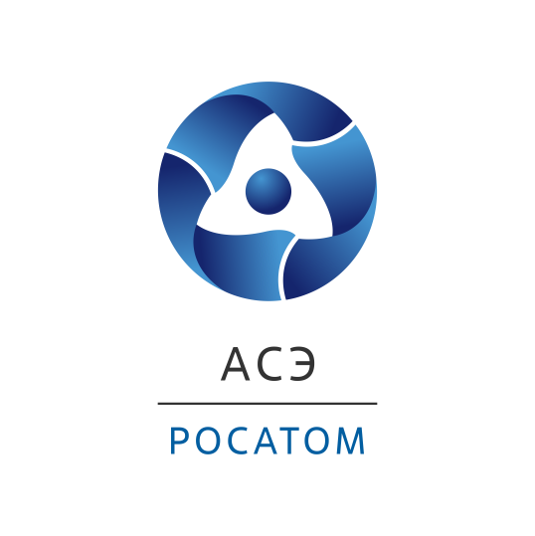

**Rosatom State Corporation Engineering Division**

**June 21, 2023**

**At Power Unit No. 7 of Tianwan NPS, the Inner Containment Dome’s Upper Part Has Been Installed in the Reactor Building**

In the reactor building of Tianwan NPS power unit No. 7, which is being built in China with involvement of the Rosatom Engineering Division, the upper part of the inner containment dome weighing 214 tons and being 36 meters in diameter has been installed in the design position.

“The construction of Tianwan NPS Unit 7 is proceeding right on time. The next step will be to install the key equipment inside the reactor building, i.e. the reactor pressure vessel, steam generators, hydraulic tanks of the emergency core cooling system, pressurizer, main circulation pumps," said Alexey Bannik, Atomstroyexport JSC Vice President for Projects in China and Prospective Projects.

The works to install the inner containment dome were carried out in two stages. Earlier, on May 19, the lower part of the dome being 44 meters in diameter and weighing 391 tons, was installed on the containment’s cylindrical part in the reactor building. For this end, a crane with a maximum 2000t lifting capacity had been delivered to the construction site.

The reactor building is the main NPP building of the nuclear power plant, to house the nuclear steam supply system and its emergency cooling systems. Using a double containment in the design ensures that the impact of radioactive products’ accidental releases into the environment is reduced as much as possible. This is provided through the use of a reinforced concrete structure to protect the reactor plant from external impacts and withstand an earthquake, tsunami or hurricane.

**For reference:**

The double protective containment is a distinctive feature of the Russian design of power units equipped with VVER-1200 reactors to ensure the highest safety level.

The external containment provides physical protection of the inner containment against external impacts.

The inner containment is constructed from pre-stressed reinforced concrete and consists of a cylindrical part and a hemispherical dome. The containment’s inner surface is lined with metal, to ensure the containment tightness in all modes of NPP operation, including emergency ones. The inner containment is one of the key localizing safety systems.

Tianwan NPS is the largest project of economic cooperation between Russia and China. Currently, two power units equipped with a VVER-1200 reactor plant are being constructed according to the Russian design. The earlier four units of the Russian VVER-1000 design are successfully operating and delivering millions of kWe to the national power grid. On June 8, 2018, an Intergovernmental Minutes of Meeting and a Frame Contract for construction of Power Units Nos. 7&8 with VVER-1200 reactors were signed in Beijing. The contract was signed by the Rosatom State Corporation Engineering Division and CNNC companies on behalf of the Russian and Chinese sides, respectively. In accordance with these documents, the Russian side has designed the NPP nuclear island and it is going to supply the key nuclear island equipment for both units. The following executive contracts were also signed such as: the technical design contract for Units 7&8 and the general contract for Units 7&8. In accordance with these contracts, the Engineering Division is in charge of design and delivery of the nuclear island equipment and documentation and provision of associated services (such as designer supervision, installation supervision, adjustment supervision). The works on construction of Units 7&8 started on May 19, 2021.

Russia is following the path of mutually beneficial cooperation with friendly countries. The implementation of major energy sector projects is underway. Rosatom's involvement in the China projects demonstrates the meaningful partnership that opens up new vistas in the area of low-carbon generation.

*The Rosatom State Corporation Engineering Division unites the leading companies of the nuclear industry, namely: Atomstroyexport JSC (Moscow, Nizhny Novgorod, branches in Russia and abroad), Joint Design Institute - Atomenergoproekt JSC (Moscow, Nizhny Novgorod, St. Petersburg branches - design institutes, branches in Russia and abroad, R&D branches) and subsidiary construction organizations.*

*The Engineering Division ranks first in the world by the order portfolio and the number of NPPs constructed simultaneously across the world.*

*About 80% of the Division’s revenues originate from foreign projects.*

*The Engineering Division implements construction projects for high-power NPPs in Russia and across the world, renders a full range of EPC, EP, EPC(M) services including project management and design activities, and develops Multi-D technologies for the management of complex engineering facilities. The Division relies on the achievements of the Russian nuclear industry and innovative state-of-the-art technologies.*

*We construct reliable and safe NPPs with* Gen III+ *VVER reactors that are in line with all international requirements and recommendations.*

[*www.ase-ec.ru*](http://www.ase-ec.ru/)