Akkuyu Mascot

The loggerhead sea turtle (lat. Caretta caretta) is an unofficial mascot of the Akkuyu Nuclear Power Plant. It was chosen as the mascot because a large nesting area of loggerheads is located not far from the construction site, near the town of Tashuçu, on a 35-kilometer coastal stretch at the Göksu river delta.

Loggerheads are the only representatives of their genus. They migrate to long distances but return to where they were born to lay eggs. Each turtle lays an egg clutch in its ‘own’ place. Hatchlings emerge all together at the same time.

Having an average lifespan of 47 to 62 years, the adult loggerhead measures 115 to 150 cm and weighs 70 to 90 kg. Loggerheads can reach the swimming speed of 35 km/h. A hatchling can swim 20 hours without stopping.

The turtle’s strong shell can withstand a load that is two hundred times higher than the reptile’s weight. The turtles are believed to recognize and remember human faces, understand the dolphin language, and use the Earth's magnetic field for orientation.

Due to the population decline, the loggerhead sea turtle is on the international list of endangered species. Unfortunately, it is extremely difficult to count the exact number of loggerheads in the wildlife. Their populations are scattered, and they make long migrations. Since turtles are hunted mercilessly for their shells, their population has decreased dramatically.

Akkuyu Nuclear has launched an initiative to support Turkish researchers who work to preserve the population of these rare reptiles in association with the Ministry of Environment and Urban Planning of Turkey.

The initiative provides for:
- Study, monitoring and protection of the sea turtles inhabiting the area near the nuclear construction site;
- Training courses for teachers and businessmen on the sustainable use of natural resources and protection of sea turtles;
- Involvement of local residents in sea animal protection programs;
- Recruitment of sea turtles to maintain and increase their population and avert the danger of extinction.

Note
The mascot is based on a drawing made by the child of an Akkuyu employee for the children’s drawing contest dedicated to the nuclear power plant. The drawing depicts a sea turtle with a helmet instead of the shell.

Loggerhead turtle at sea | Child’s drawing | Mascot
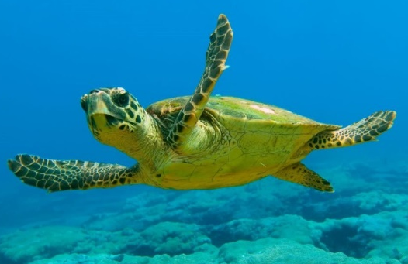 | 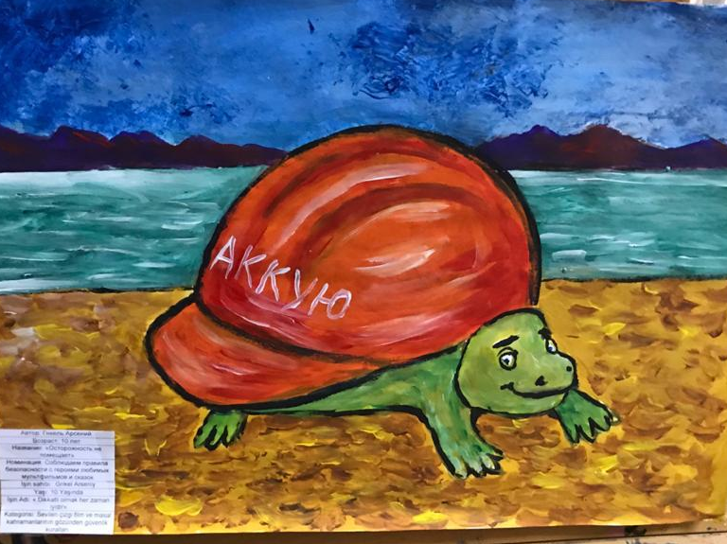 | 